Dashboard Design

Date | 04 October 2025
Team ID | PNT2022TMIDxxxxxx
Project Name | Global Malnutrition Trends: A Power BI Analysis (1983-2019)
Maximum Marks | 5 Marks

Creating an effective dashboard involves thoughtful design to ensure that the presented information is clear, relevant, and easily understandable for the intended audience. Here are some key principles and best practices for dashboard design
Interactive and Visually Appealing Dashboard
To ensure the dashboard is engaging and useful for policymakers, researchers, and stakeholders, the following design principles were applied:
- Clear and Intuitive Layout: Dashboard sections are divided by malnutrition indicators (underweight, overweight, stunting, wasting).
- Appropriate Visualizations: Line charts for time trends, bar charts for country-level comparisons, ribbon charts for overweight vs underweight, and maps for regional distribution.
- Color and Theming: Consistent use of colors — red/orange for undernutrition, green for healthy indicators, and blue for overweight — to improve clarity.
- Interactive Filters and Slicers: Filters by country, income level (low, lower-middle, upper-middle, high), and special categories (LDC, LIFD, LLDC, SIDS).
- Drill-Down Capabilities: Ability to move from global trends → region → country → year for deeper insights.
- Responsive Design: Dashboard optimized for different screen sizes (desktop and projection).
- Custom Visuals and Icons: Use of icons for children, regions, and income groups to improve user experience.
- Use of Infographics: Key metrics (Survey Sample Size, Underweight Cases, U5 Count) highlighted with infographic-style cards.

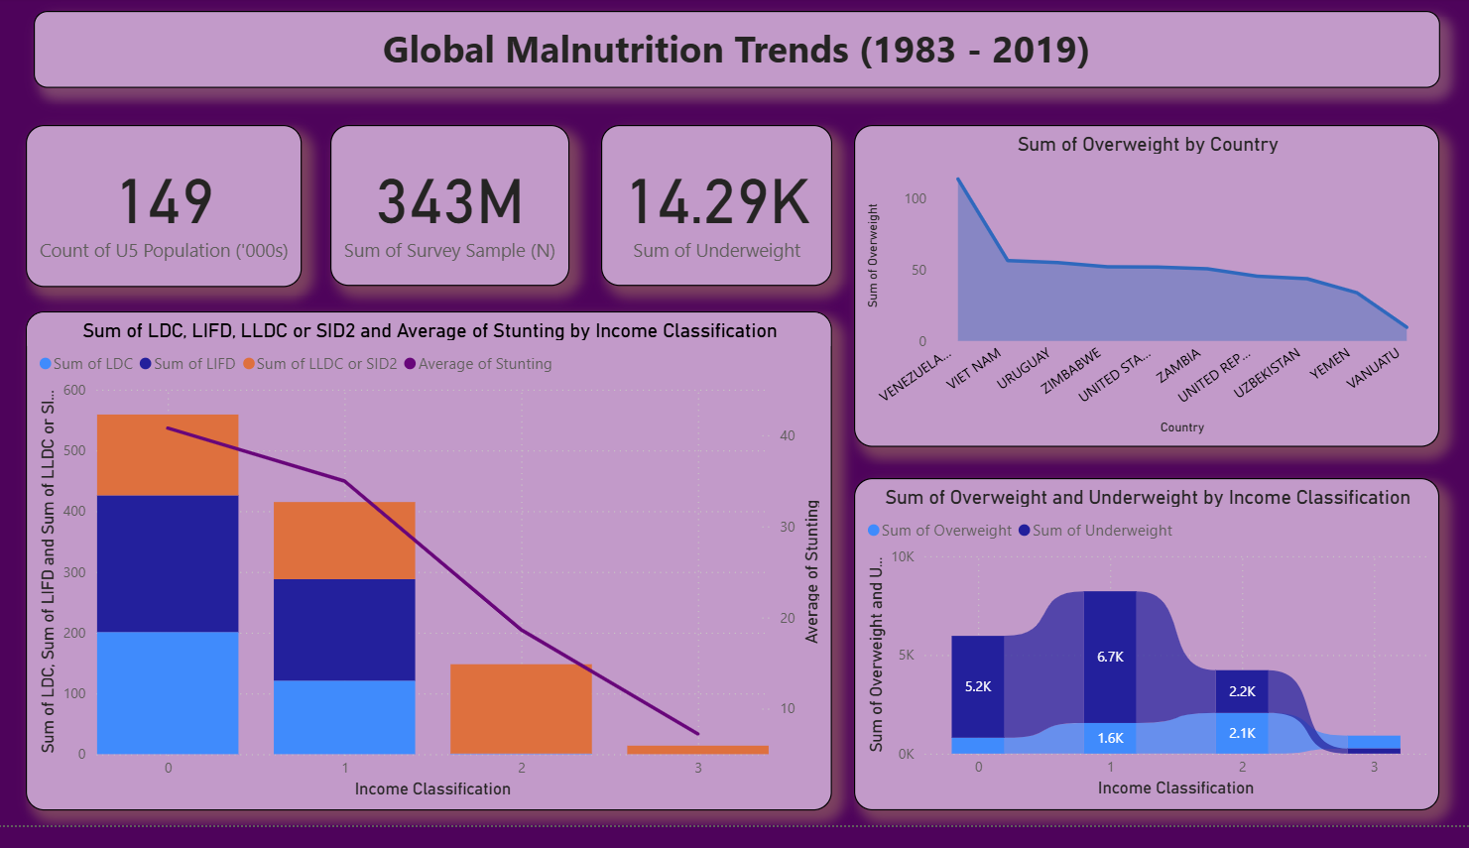
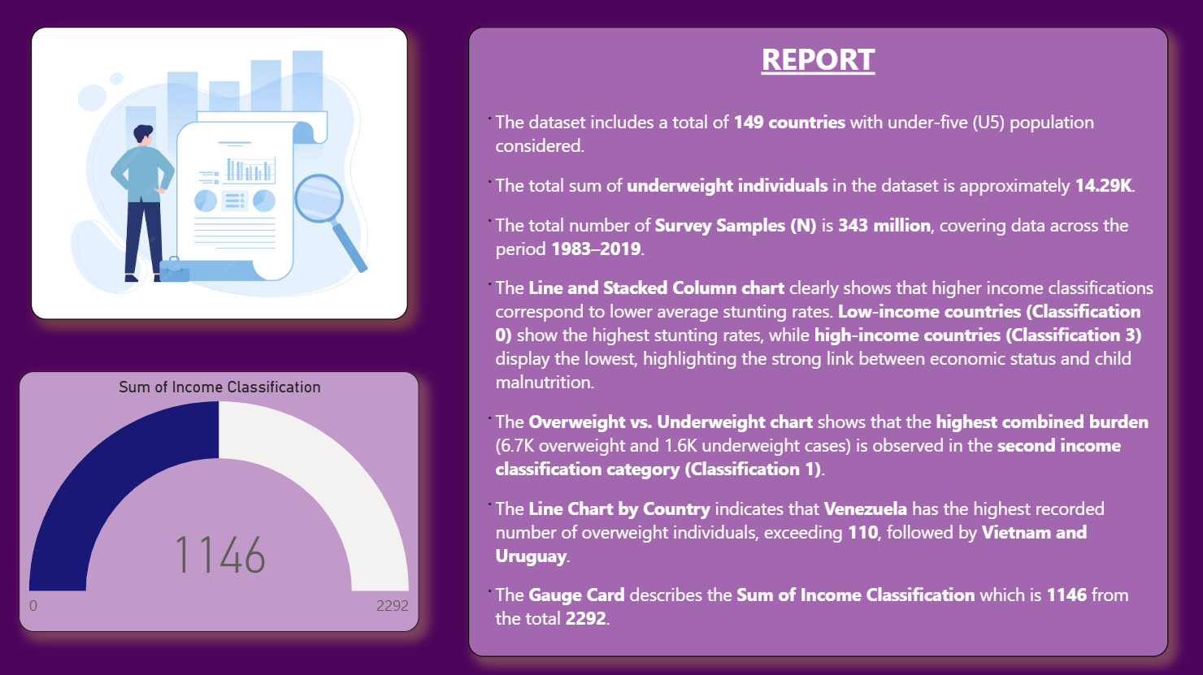
Major Outcomes from the Dashboard
- Survey Sample Coverage: The dataset includes 11 million survey samples, ensuring robustness of findings.
- Underweight Cases: A total of 2,080 underweight cases were recorded, highlighting critical areas of child undernutrition.
- Stunting vs Income Levels: Visualization shows a clear negative correlation — higher income groups experience lower stunting rates.
- Overweight Trends by Country: Certain high-income countries show rising overweight levels, indicating the double burden of malnutrition.
- Overweight vs Underweight Analysis: Ribbon chart demonstrates that low-income countries struggle more with underweight, while high-income countries face overweight issues.
- Income Classification Distribution: Pie chart highlights the spread of countries across low, middle, and high-income groups.
- Regional Vulnerability: LDC and LLDC countries show the highest malnutrition rates, requiring urgent intervention.
- Time Trends (1983–2019): Line charts reveal gradual improvement in some indicators, but progress is uneven across regions.

